# Time Series Analysis

## Overall Trends

* **Pre-pandemic Growth Trend (2003–2019):** The number of visitors shows a gradual upward trend before the pandemic. There is some fluctuation around 2009, which could be attributed to the global financial crisis, affecting visitor numbers temporarily.
* **Pandemic Impact (2020–2022):** There is a sharp decline in visitor numbers around 2020, coinciding with the outbreak of the COVID-19 pandemic. The border closures and travel restrictions during this period are likely responsible for the near-complete cessation of international tourism.
* **Post-pandemic Recovery (2023–2024):** After 2022, visitor numbers start to recover as countries ease their pandemic-related restrictions. However, the levels have not yet reached the pre-pandemic peaks seen in 2016–2017, indicating that the recovery is ongoing but still incomplete.

## Seasonal Impact on Visitor Numbers (2003–2024)

### Pre-COVID-19 Trends (2003–March 2020):

Before March 2020, seasonal effects on the number of visitors to New Zealand were clearly pronounced. A linear regression model for this period reveals the following insights:

•**Summer** served as the baseline season, with an average of 185,689 visitors.

•During **Autumn**, there was a decrease of 74,831 visitors compared to summer.

•**Winter** saw the most significant drop, with 107,126 fewer visitors compared to summer.

•In **Spring**, visitor numbers were lower by 71,970 compared to summer. 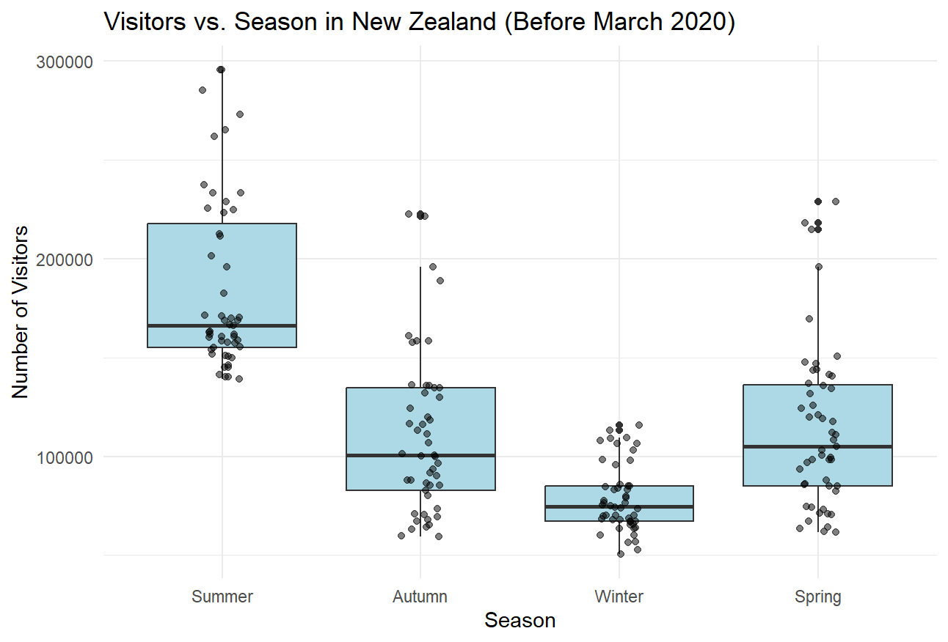

The adjusted R-squared value of 0.522 suggests that more than 50% of the variation in visitor numbers could be explained by seasonality alone before the pandemic. This higher value indicates that seasonality was a dominant factor influencing tourist arrivals during this period. A computer screen shot of a number

### Overall Trends on Season(2003–2024):

When analyzing the entire time series, including the pandemic period, the impact of seasonality on visitor numbers is still evident, though external factors, such as the COVID-19 pandemic, introduce greater variability. The linear regression model for the full time span shows:

•**Summer** remains the baseline season, with an average of 167,296 visitors.

•During **Autumn**, there is a reduction of 69,800 visitors compared to summer.

•**Winter** exhibits a substantial decrease, with 98,466 fewer visitors than in summer.

•In **Spring**, visitor numbers drop by 66,085 compared to summer.

The adjusted R-squared value for this period is 0.327, reflecting that while seasonality remains an important factor, external shocks, particularly the pandemic, have disrupted normal patterns and reduced the model’s overall fitness. Despite this, seasonality continues to play a significant role in shaping visitor trends, albeit with reduced explanatory power due to recent disruptions.

# Recovery of Visitor Visa Tourist

Based on the analysis, although New Zealand’s tourism industry has shown signs of recovery after the pandemic, the number of Visitor Visa tourists has not yet returned to pre-pandemic levels. Below are the detailed figures and analysis:

* Total Visitor Visa Tourists in 2019: 2,076,186
* Total Visitor Visa Tourists in 2023: 1,420,358

The recovery rate of 68.41% by 2023 indicates that the number of Visitor Visa tourists is still below the peak level seen before the pandemic. The recovery is ongoing but relatively slow.



Since the data for 2024 is still incomplete, it is recommended to conduct another analysis after the end of 2024.

# Country of Origin Analysis (2020–2024)

## Top 10 Home Countries of Visitors

The analysis of visitor arrivals by country of origin from 2020 to 2024 reveals essential insights about the recovery trajectories of different markets post-pandemic:

•**Australia:** Continues to lead as the largest source of visitors. Visitor numbers dipped significantly in 2021 due to the pandemic but rebounded strongly by 2023 and 2024.

•**United States and United Kingdom:** Both countries exhibited a strong recovery after 2022, with steady growth in 2023 and 2024.

•**China:** Demonstrated the fastest growth rate among non-English-speaking countries, rebounding sharply from the low point in 2021.

•**European Countries:** Germany and France showed slower but consistent growth in tourist arrivals.

## Yearly Growth Rates among Top 10 Home Countries

•**Australia and the United States** showed the highest recovery rates after 2021, indicating that these markets are critical for New Zealand’s tourism revival. Their growth was particularly significant in 2023 and 2024.

•**China**: The fastest-growing market post-2022, making it a priority for targeted marketing and service customization.

•**Europe**: Countries such as Germany and the U.K. maintained stable growth, though at a slower pace than the U.S. and China.

•**Japan and South Korea**: Steady recovery in tourist numbers highlights the importance of these markets moving forward.

# Recommendations

## Seasonal Tourism Management & Adapt to Post-Pandemic Dynamics

•Summer Tourism: With summer continuing to attract the most visitors, investments should focus on managing peak demand. Expanding infrastructure to cope with high visitor volumes and offering premium experiences during this season can enhance visitor satisfaction.

•Year-Round Tourism: Given the irregular recovery patterns after COVID-19, New Zealand must promote year-round tourism with flexible travel options. Encouraging seasonal discounts can help maintain visitor numbers even during off-peak seasons.

•Health and Safety: As post-pandemic tourists may prioritize health and safety, ensuring that New Zealand is marketed as a safe destination will attract a broader range of international visitors.

## Target Non-English-Speaking Markets

•Multilingual Services: The growing number of visitors from China, Japan, and Germany necessitates enhanced language support. Providing multilingual signage, translation services, and tailored tour packages for these markets will improve visitor experiences and encourage repeat visits.

•Customized Travel Experiences: Catering to the cultural preferences of key markets, such as offering adventure tours for German tourists and shopping tours for Chinese visitors, will increase satisfaction and spending.

## Strategic Marketing and Resource Allocation

•Australia and U.S. Focus: With Australia remaining the largest visitor market, continuing to invest in infrastructure and services tailored to Australian tourists is crucial. Similarly, the U.S. market could be prioritized with investments in high-end resorts and experiences.

•Chinese Market Expansion: China’s rapid post-pandemic growth suggests the need for targeted marketing campaigns, particularly on platforms which are popular among younger Chinese travellers.

## Infrastructure and Digital Innovation

•Foreign Language Guides: The increasing demand for foreign language guides, especially from China, Japan, and Germany, requires investment in multilingual training for tour operators and the developing of digital guides and apps.

# Data and Pre-processing.

Study on home countries:

<https://www.stats.govt.nz/assets/Uploads/International-travel/International-travel-May-2024/Download-data/international-visitor-arrivals-to-new-zealand-may-2024.xlsx>



Study on Time Series (Header row and description rows removed for CSV reading)

<https://infoshare.stats.govt.nz/FileDownload.aspx?fileName=ITM524901_20240902_114033_41.csv&contentType=text%2fcsv>

